**News Tracker Application**

ASSIGNMENT 1

| Batch | B7-1A3E |
| --- | --- |
| Team Id | PNT2022TMID50567 |
| Student Name | Anitha A |
| Student Register Number | 952819104008 |
| Task | Task - 2 |

Task - 1:

Develop a flask program which should contain at least 5 packages used from pypi.org.

Code:

[https://github.com/IBM-EPBL/IBM-Project-47890-1660803089/tree/main/Assignments/Assignment1/Program2](https://github.com/IBM-EPBL/IBM-Project-47890-1660803089/tree/main/Assignments/Assignment1/Program1)

Output:

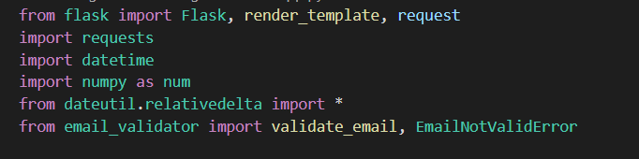

Knowledge by Age:-

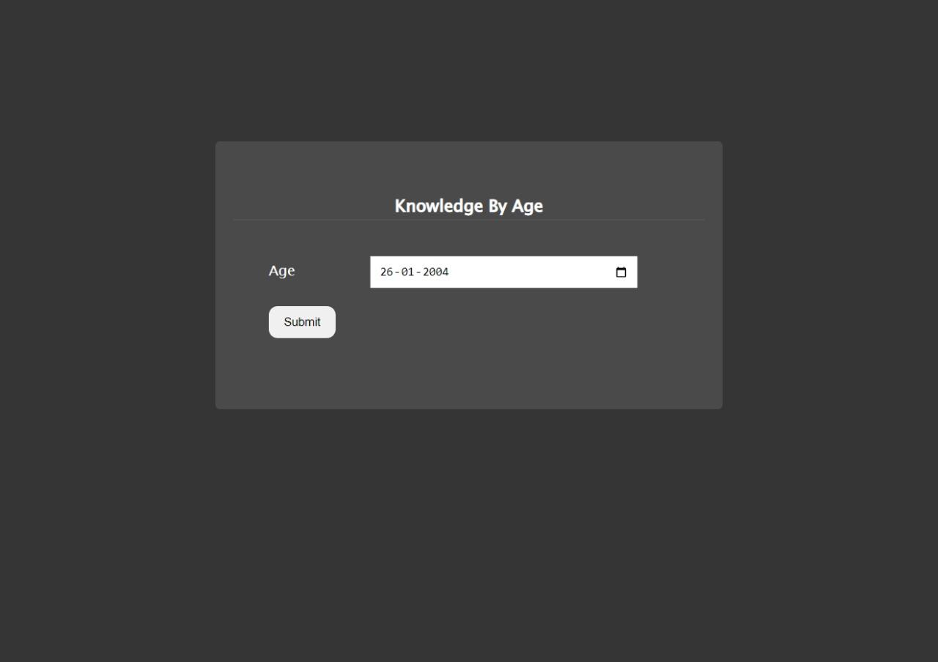

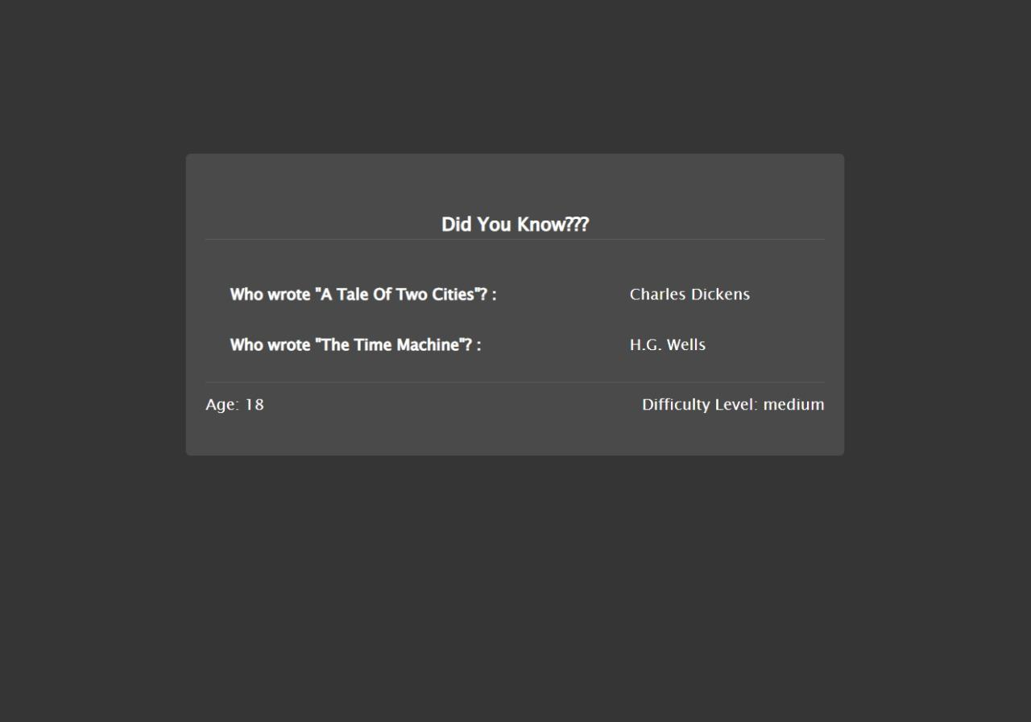

Difficulty level of Questions are decided by Date of Birth(Age)

Process:-

1.User Enters Date of Birth

2.Age is Calculated.

3.Based on age,difficulty level is decided.i.e.,age less than 15 means easy level of questions are fetched from api.

MailId Validator:-

